Afbeelding met schermopname, Lettertype, zwart

Door AI gegenereerde inhoud is mogelijk onjuist.Afbeelding met Lettertype, Graphics, symbool, logo

Door AI gegenereerde inhoud is mogelijk onjuist.

Soil sensors 2

|  |  |
| --- | --- |
| Authors  Intern | Emiel Mangelschots  Kobe Jacobs  *Patrick Hilven* |

Abstract

This application note presents the design and implementation of a wireless soil monitoring system using TEROS 12 sensors and an ESP32 microcontroller. The TEROS 12 sensors measure volumetric water content (VWC), temperature, and electrical conductivity (EC), and communicate using the SDI-12 protocol. Sensor data is transmitted over Wi-Fi to a Loxone smart automation controller using UDP packets. The system features hardware-level voltage translation, addressable sensor communication on a shared SDI-12 bus, and a custom-made PCB layout suitable for greenhouse deployment. This project enables efficient environmental monitoring for precision agriculture.

Contents

Introduction 3

Hardware 3

PCB 3

Block diagram and schematic 3

PCB layout 5

Connectors 6

Sensors 7

Housing 8

Software 8

ESP32 (Sender) 9

Loxone Mini server (Receiver) 10

Results 11

Discussion 12

Conclusion 13

# Introduction

In modern agriculture, accurately monitoring soil and environmental conditions is essential for efficient and automated cultivation. This project focuses on the development of a wireless sensor platform using TEROS 12 soil sensors and an ESP32 microcontroller that communicates via the SDI-12 protocol to collect real-time data and transmit it over Wi-Fi to a Loxone controller.

The sensors measure three critical soil parameters: volumetric water content (VWC), temperature, and electrical conductivity (EC). SDI-12, a standardized serial communication protocol for environmental sensors, required specific hardware-level adaptations and custom software integration to ensure compatibility with the ESP32's 3.3V logic.

The assignment tasked students with implementing a prototype system that reads soil and environmental data using the TEROS 12 and BME280 sensors and transmits it wirelessly to a Loxone controller. Loxone is responsible for evaluating the received sensor data and using it to alert users via GSM and control actuators such as fans or irrigation systems via digital outputs.

The system uses UDP packets to send sensor readings to the Loxone Mini server. In addition to reading and addressing multiple sensors on a shared data line, a test procedure was developed to verify sensor accuracy under various conditions including dry air, moist soil, and elevated temperatures.

This application note documents the full process from research and design to implementation and validation of a functional prototype for wireless soil monitoring.

# Hardware

## PCB

The hardware consists of an ESP32 module, level shifters for SDI-12 voltage adaptation, screw terminals for sensor and power connections, and connectors for signal routing.

### Block diagram and schematic

The hardware is implemented on a custom-designed PCB built on a prototyping board, divided into logical sections for clarity and modularity. The layout is optimized to support the 5V-powered TEROS 12 sensors while ensuring compatibility with the 3.3V logic of the ESP32.

The bottom layer consists of multiple zones:

* **ESP_WROOM_32 section**: Central component that controls communication, parsing, and Wi-Fi transmission. The ESP32 receives data through a GPIO pin connected to the SDI-12 bus.
* **5V Input section**: A screw terminal block (J5) connects the battery pack or external power source, supplying 5V to the sensor circuits and level shifters.
* **Logic Level Headers section**: Contains 4-pin and 6-pin JST-style headers (J1–J4) to connect TEROS 12 sensors. These headers route power (5V), ground, and SDI-12 data lines through level shifters to the ESP32.

Afbeelding met tekst, lijn, diagram, schermopname

Door AI gegenereerde inhoud is mogelijk onjuist.

*Fig 1: Bottom layer*

The layout also includes bi-directional logic level converters (TXS0108E or similar) to translate the SDI-12 signal from 5V (sensor side) to 3.3V (ESP32 side). These level converters are connected in-line between the sensor headers and the ESP32's GPIO pin designated as the SDI-12 data line.

Afbeelding met tekst, schermopname, diagram, Rechthoek

Door AI gegenereerde inhoud is mogelijk onjuist.

*Fig 2: Top layer*

The top layer consists of three main sections:

**5V Input section**: A 2-pin terminal connector (J6 – 1729128) provides power to the system.

* Pin 1 supplies **5V_IN** to the sensors and logic level converters.
* Pin 2 connects to the **GND_CMN** ground plane.  
  This section serves as the main power entry point for the entire top layer circuit.

**Logic Level Converter section**: Two BOB-12009 level shifter modules interface between the 5V SDI-12 sensor signals and the 3.3V ESP32 logic.

* The **LV pin (Pin 3)** is connected to **3.3V_OUT** from the ESP32.
* **Pins 1, 2, 5, and 6** on the low-voltage side are connected to the **DATA** line (ESP32).
* **Pins 7, 8, 11, and 12** on the high-voltage side are connected to the **DATA_SEN** line going to the sensors.
* **Pin 10** is supplied with **5V_IN**, while **Pins 4 and 9** are tied to **GND_CMN**.  
  This setup ensures bi-directional level translation between ESP32 and sensors, compliant with SDI-12 voltage requirements.

**Sensor Headers section**: Three 6-pin connectors (J7, J8, J9 – 691709710306) provide interfaces for TEROS 12 sensors.  
Each header includes:

* **5V_IN** (Pins 1 and 4)
* **DATA_SEN** (Pins 2 and 5)
* **GND_CMN** (Pins 3 and 6)  
  All headers are wired identically and allow sensors to operate in parallel on the same SDI-12 data line, while sharing a common power and ground connection.

The top layer is carefully structured to ensure clean power routing, proper logic level isolation, and simple, modular connection of multiple sensors for reliable field deployment.

### PCB layout

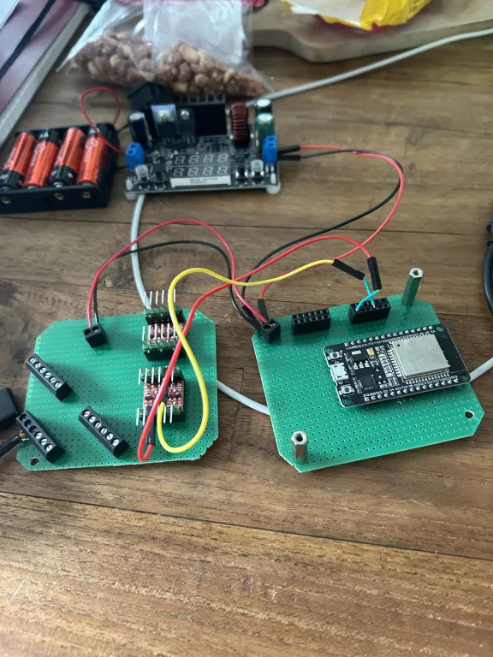Due to size constraints, the PCB was split into two boards. The design uses a prototyping perforated board with all essential components soldered and mounted compactly to fit the enclosure.

Holes have also been made in the PCB to place a spacer in between and the corners have been cut off so that it fits in the casing.

*Fig 3: PCB layout*

### Connectors

#### Terminal Blocks

A 2-pin terminal block (J6) is used to provide external 5V power to the system. This connector is connected directly to the enclosure’s power jack, enabling easy integration with a battery pack or standard DC adapter.

* **Pin 1** connects to the shared **5V_IN** rail.
* **Pin 2** connects to **GND_CMN** (common ground).

This allows the controller to be powered independently of the ESP32’s USB port, which is reserved for programming and debugging purposes. *Fig 4: Terminal Block*

#### Headers

Three 6-pin sensor headers (J7, J8, J9) are used to connect up to six TEROS 12 soil sensors. Each header provides:

* **5V_IN** (Pins 1 and 4)
* **DATA_SEN** (Pins 2 and 5)
* **GND_CMN** (Pins 3 and 6)

All headers are wired identically to allow sensors to operate in parallel on the same SDI-12 data line, while maintaining isolated power and ground for each.

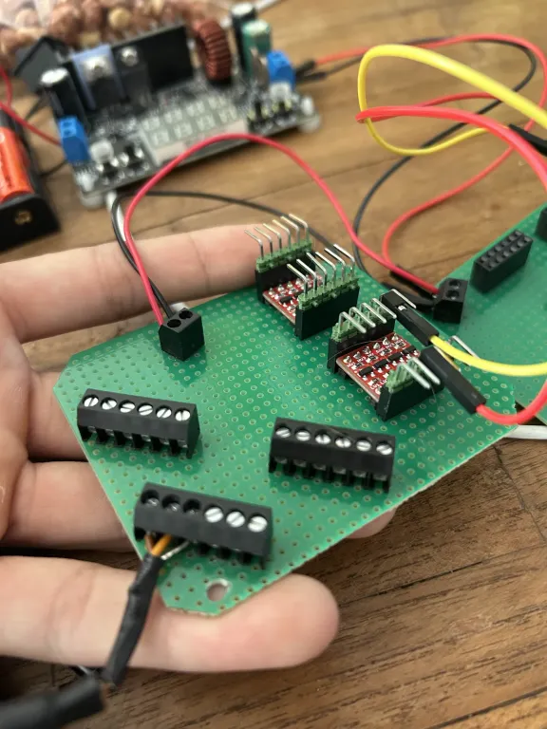Additionally, two logic level converter modules are connected via pin headers to route the SDI-12 data line between the 5V sensor side and the 3.3V ESP32 side. The headers are clearly marked and organized to ensure modularity and expandability.

These connectors make the system robust, serviceable, and suitable for integration in greenhouse environments where quick sensor replacement or scaling is needed.

*Fig 5: Pin headers and sockets*

## Sensors

#### TEROS 12 (METER Group)

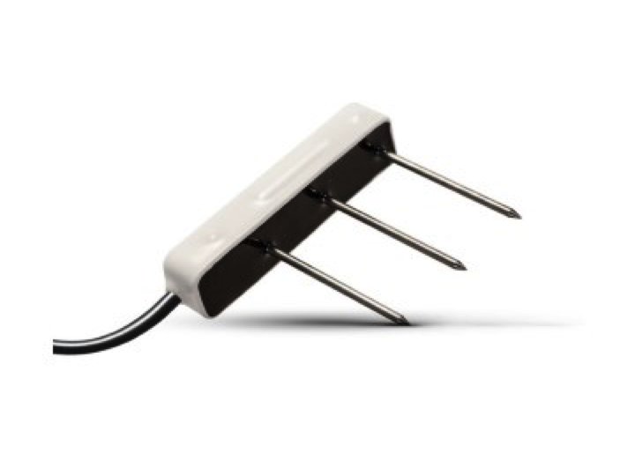The TEROS 12 sensor, developed by METER Group, is a high-accuracy, ruggedized environmental sensor designed to measure **volumetric water content (VWC)**, **electrical conductivity (EC)**, and **temperature** in soils. It utilizes advanced **dielectric permittivity sensing at 70 MHz**, minimizing measurement errors caused by soil texture, salinity, or bulk density—making it highly suitable for a wide range of soil types and agricultural applications.

*Fig 6: TEROS 12 sensor*

The sensor features a **three-prong stainless steel electrode array** that enhances insertion durability and improves contact with the soil for more consistent EC and VWC measurements. A high-precision thermistor is integrated into the sensor body to provide accurate temperature readings.

A key advantage of the TEROS 12 is its full compatibility with the **SDI-12 v1.3 communication protocol**, which allows for **multi-drop configuration** on a single three-wire bus (power, ground, and data). This enables users to deploy multiple sensors in parallel, each with a unique SDI-12 address, and retrieve data efficiently using standard digital commands.

The SDI-12 interface on the TEROS 12 supports a wide command set:

* The **Identification command** (aI!) returns details such as sensor address, vendor ID, model number, firmware version, and serial number.
* The **Measurement command** (aM!) instructs the sensor to initiate a reading cycle.
* The **Data command** (aD0!) retrieves the most recent VWC, EC, and temperature measurements in a formatted ASCII response.

The TEROS 12's default address is "0", but it can be reprogrammed using the **Change Address command** (aAb!) to avoid address conflicts in multi-sensor setups. This functionality was critical in this project for sequentially polling multiple sensors over a shared SDI-12 line using a single GPIO pin.

With its **low power consumption**, **sealed epoxy housing**, and **digital accuracy**, the TEROS 12 is well-suited for long-term, low-maintenance deployments in both research and commercial greenhouse environments. Its robust construction and ease of integration with microcontrollers like the ESP32 make it an ideal component for scalable soil monitoring systems.

We initially encountered decoding issues due to extra string headers from the TEROS 12's SDI-12 output. These were resolved by filtering for only numeric characters and parsing the payload correctly. For detailed electrical specifications, command structure, and deployment best practices, users are advised to refer to METER Group’s **TEROS 12 Integrator Guide** and the **SDI-12 v1.4 standard documentation**.

## Housing

The system is housed in a **HENSEL KF 0200 B enclosure**, a compact and durable plastic junction box designed for industrial applications. This enclosure was provided by the course instructor and offers a robust protective casing for outdoor or greenhouse environments.

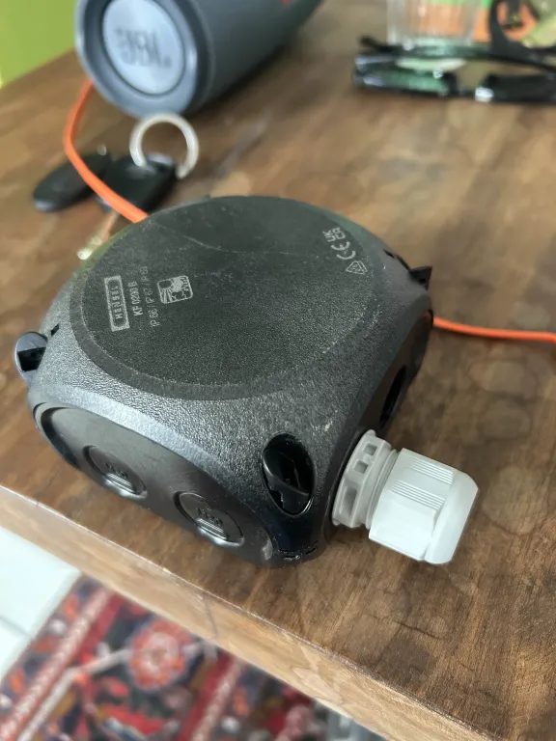To accommodate both PCBs, the interior of the enclosure was manually **filed down**, allowing the components to fit snugly while maintaining mechanical stability. The design ensures that **all screw terminals and headers remain accessible** from the outside, simplifying sensor installation and system maintenance. To protect the electronics from moisture, a custom insert was added at the cable entry point, allowing the sensor cables to pass through while sealing the opening. This helps to prevent water ingress into the housing, making the system more robust and suitable for greenhouse or outdoor use.

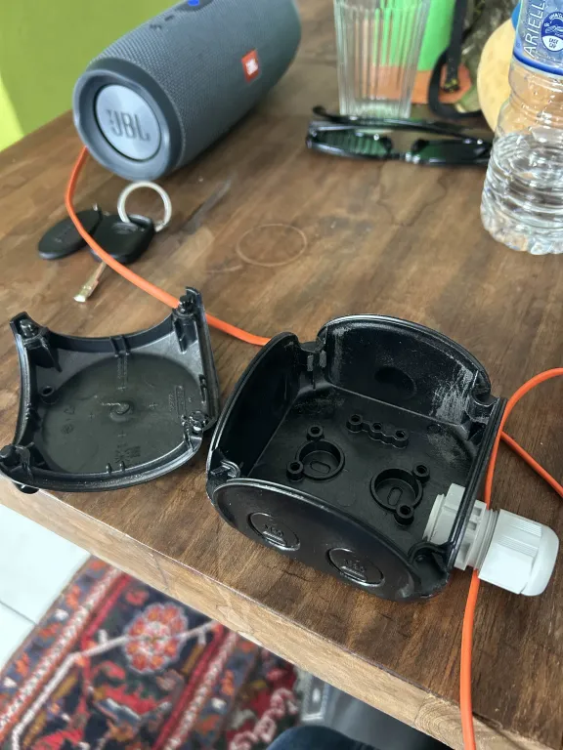*Fig 7: Housing closed*

*A* custom cable insert *was mounted on the enclosure to guide the TEROS 12 sensor cables inside the housing. This insert not only facilitates organized cable management but also acts as a* seal to prevent water ingress*, thereby protecting the internal electronics from humidity and environmental exposure.*

*Fig 8: Housing open*

*This enclosure solution ensures a reliable and weather-resistant installation, suitable for long-term deployment in greenhouse or semi-outdoor settings.*

# Software

The application software was developed entirely in the **Arduino IDE for the ESP32 microcontroller**. The ESP32 functions as a standalone sensor node responsible for gathering, processing, and transmitting environmental data.

Unlike systems with multiple microcontrollers, this setup uses a **single ESP32** to handle both the communication with the TEROS 12 soil sensors via the SDI-12 protocol and the wireless data transmission to the Loxone controller over Wi-Fi. This simplifies the architecture while maintaining reliability and expandability.

In the following sections, we provide a detailed explanation of the implementation and highlight several challenges encountered during development, such as SDI-12 communication issues, multi-sensor address conflicts, and parsing irregularities in the sensor response format.

### ESP32 (Sender)

In this project, the ESP32 microcontroller acts as the **sensor node and data transmitter**. It is responsible for reading values from one or more TEROS 12 soil sensors via the SDI-12 protocol and transmitting the collected data to a Loxone controller over Wi-Fi using UDP packets.

The firmware was developed in the **Arduino IDE** using several key libraries:

* SDI12.h to communicate with the TEROS 12 sensors via a digital GPIO pin (configured as a half-duplex data line),
* WiFi.h and WiFiUDP.h to handle Wi-Fi connectivity and UDP communication.

Upon startup, the ESP32 initializes the SDI-12 interface and connects to a specified Wi-Fi network. Once connected, it enters a loop where it continuously polls the sensors.

The TEROS 12 sensors use the SDI-12 command set:

* The "aM!" command instructs the sensor to begin a measurement cycle.
* The "aD0!" command retrieves the most recent data set, which contains **VWC**, **temperature**, and **electrical conductivity (EC)**.

The raw SDI-12 response is received as a string. A **custom parser** processes this response by:

1. Filtering out irrelevant characters to isolate only numeric data,
2. Removing sensor-specific headers (such as "000130+"),
3. Splitting the string at "+" characters to extract each individual value.

Each measurement is then converted into a float and labelled:

* VWC (µS/cm)
* Temperature (°C)
* EC (%)

Once the values are extracted, they are formatted into a readable string such as:

*VWC: 532.00, Temp: 24.50, EC: 8.50*

This string is then sent as a **UDP packet** to the Loxone Mini server, configured with IP 192.168.1.77 and port 50001.

The ESP32 supports reading from **multiple sensors on a shared SDI-12 bus**. Since each TEROS 12 has a default address of 0, sensors must be assigned unique addresses via the aAb! command. Once addressed, the ESP32 can poll them sequentially.

This approach enables centralized collection and wireless transmission of soil condition data in real-time, fulfilling the sender role in a modular, distributed environmental monitoring system.

### Loxone Mini server (Receiver)

The **Loxone Mini server** serves as the **receiver and central automation controller** within the overall system. It is responsible for receiving UDP packets containing sensor data from the ESP32 and taking appropriate actions based on predefined logic.

The ESP32 sends the environmental data, volumetric water content (VWC), temperature, and electrical conductivity (EC) via **UDP** to the Mini server at IP address 192.168.1.77 and port 50001. The Loxone system uses a **UDP Input block** within the Loxone Config software to capture and interpret this incoming data.

Once received, the data string is parsed and processed using built-in logic blocks, allowing the system to:

* Trigger user notifications via **SMS** using the GSM extension module,
* Activate actuators such as **irrigation valves** or **ventilation systems** based on sensor thresholds,
* Log historical data for analysis or long-term monitoring.

**Note:** The configuration and integration of the Loxone Mini server was developed as part of a parallel student project. While our group focused on the ESP32-based sensor node and data transmission, a separate team of students was responsible for implementing the receiver logic within the Loxone automation platform.

This collaboration highlights the modularity and interoperability of the system-sensor nodes and receivers can be developed independently, yet still operate as part of a cohesive smart control network.

With its reliable UDP handling, flexible automation logic, and integration capabilities, the Loxone Mini server completes the system by transforming raw sensor data into intelligent control actions for precision agriculture environments.

# Results

The final outcome of this project is a working prototype capable of reading, processing, and transmitting environmental data from TEROS 12 sensor to a Loxone Mini server using Wi-Fi. The prototype was fully tested under controlled conditions and met all core functionality goals.

* The system **successfully read and parsed** SDI-12 output from the TEROS 12 sensors, accurately extracting volumetric water content (VWC), temperature, and electrical conductivity (EC) values from the raw ASCII data stream. A custom parsing routine was implemented to handle unexpected characters and formatting issues within the sensor response.
* **UDP communication between the ESP32 and the Loxone controller was validated**. The formatted sensor data was correctly received by the Mini server, parsed, and processed using logic blocks for real-time monitoring and control.
* Multi-sensor functionality was demonstrated by configuring **unique SDI-12 addresses** using the aAb! command. The ESP32 successfully polled multiple sensors on a **shared data line**, confirming proper implementation of address-based sequential reading.
* The use of **bi-directional logic level converters** was verified. The system correctly shifted the 5V SDI-12 signals from the sensors to 3.3V, ensuring safe communication with the ESP32 without signal degradation or timing issues.
* A **functional PCB prototype** was created on perforated prototyping board. The layout included properly routed power, ground, and signal paths, as well as clean separation of sensor and logic voltage domains. The system remained stable under repeated testing conditions.

In future iterations, these mechanical and software refinements could be streamlined by designing a dedicated PCB with onboard address configuration and waterproof cable entry. The next logical step would be to extend the system with **data logging**, **graphical visualization**, or **remote control** functionalities based on live sensor data.

During testing of the sensor on the PCB, we observed that the board drew an unexpectedly high current, causing a voltage drop. This resulted in the supply voltage falling below the required level to properly power the TEROS 12 sensor. This issue was identified and analyzed as part of the hardware testing process.

Additionally, we experienced a temporary issue with the ESP32’s Wi-Fi connection. The microcontroller repeatedly showed connection errors, preventing data transmission to the Loxone Mini server. After investigating the error codes, it was determined to be a network configuration issue. This has since been resolved, and UDP communication is now stable.

# Discussion

The completion of this project provided valuable insights into the complexities of implementing a modular soil monitoring system using SDI-12-based TEROS 12 sensors. Initial decoding issues with the sensor output, caused by string prefixes such as “+000130+...”, necessitated updates to the parsing logic to properly trim and isolate the actual measurement values. This debugging process highlighted the importance of thorough data validation when dealing with sensor communication protocols.

A notable challenge was the operation of multiple sensors sharing the same default address ‘0’. To overcome this, it was necessary to research how to change the sensor address to individually control each sensor on the shared SDI-12 bus. This was done by sending specific address change commands, formatted as "0A1!", "0A2!", etc., where the old address is followed by an 'A' and the new desired address, terminated by an exclamation mark.

One practical limitation discovered was that the battery holder did not fit properly inside the existing casing. This constraint required redesigning the hardware layout into a split-PCB design to accommodate the physical size limitations. In hindsight, designing a custom battery holder tailored to the housing dimensions would have been a better solution to improve compactness and integration. This experience underscored the importance of considering mechanical and form factor constraints alongside electrical design in embedded system projects.

An additional challenge encountered during testing was the unexpectedly high current consumption of the system, especially when multiple SDI-12 sensors were connected. This led to a voltage drop, causing the sensors to malfunction. Future iterations should consider integrating a more robust voltage regulator or providing a dedicated power supply for the sensors to prevent this issue.

Furthermore, during development, we faced a temporary network failure where the ESP32 was unable to connect to the Wi-Fi network. This was caused by incorrect network settings on the board. After correcting these configurations, the connection was restored. This experience highlights the importance of robust error handling and logging in embedded networked systems.

# Conclusion

Looking forward, the success of this project opens doors to further research and development, with opportunities for refining the controller's design and enhancing its functionality. By addressing hardware limitations and exploring avenues for communication improvements, we can pave the way for a more robust and reliable greenhouse management solution.

Moreover, the broader implications of this project are significant. It lays the groundwork for future advancements in agricultural technology, with the potential to revolutionize farming practices and contribute to global food security. As we continue to push the boundaries of what is possible, this project serves as a testament to the value of integrating wireless sensor technology with intelligent data management.

Ultimately, the modular and scalable nature of the system positions it well for adoption in diverse agricultural environments, supporting sustainable practices and efficient resource use. This foundation encourages ongoing innovation towards fully automated, data-driven greenhouse control systems.